LAB 2 REPORT
Student Name | DANJUMA YAHAYA ADDRA | Registration No. | C113/26/OCO/17001
Programme/Cohort | OCO/Cohort11 | Date | 04/09/2026
Instructor |  | Score | /100
Environment | Kali Linux / Ubuntu | Submission | E-Campus

TASK 1 REPORT
EVIDENCE:
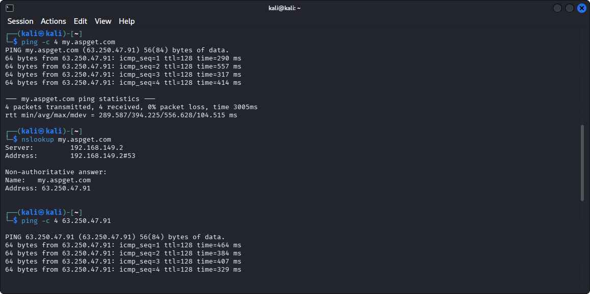
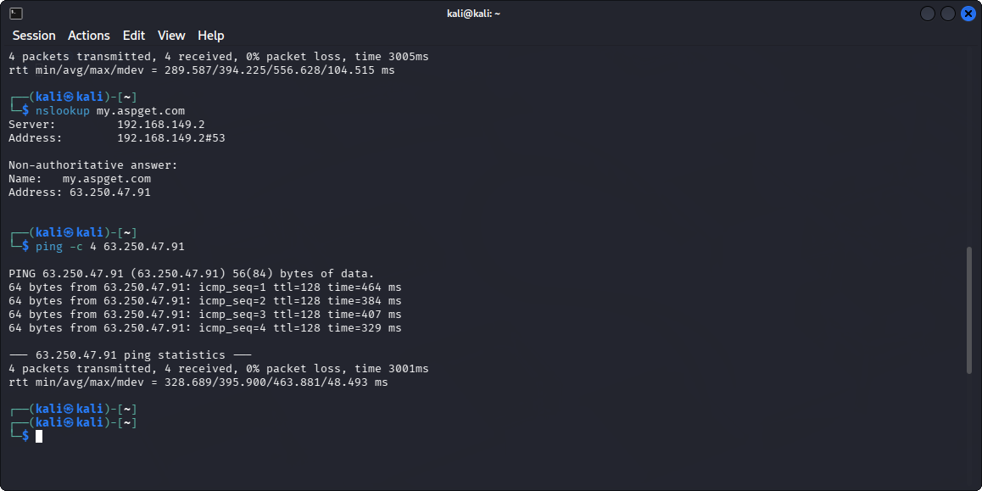
RESPONSE: There was no any extra function required when I ran or checked the website using the domain name and the IP address. It gave me almost the same result, that shows that the DNS is working perfectly in resolving the domain name to IP address.

TASK 2 REPORT
Local address and port identified
Address = 127.0.0.1
Port number = 3333
EVIDEMCE:
RESPONSE:
- listening (-l) shows the socket that is on the listening state
- numeri (-n) shows port and address as numbers instead of resolving them to domain or hostname.
- TCP (-t) shows only TCP communication protocol and not UDP
TASK 3 REPORT
Recommendation: Record whether each port is open, closed, or filtered according to your output.
Answer: I scanned the localhost on port 22 and I found out the port 22 is closed. Also the port 21 is closed

EVIDENCE:
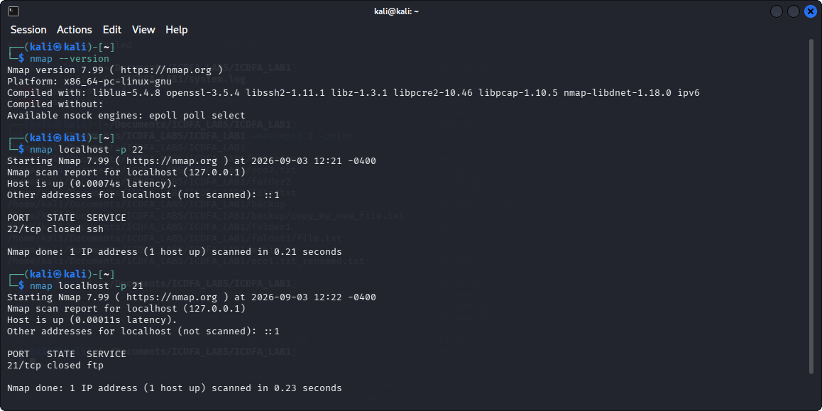
RESPONSE: If nmap report port as closed it means the target is reachable, but there is no service listening on that port.
TASK 4 REPORT
EVIDENCE:
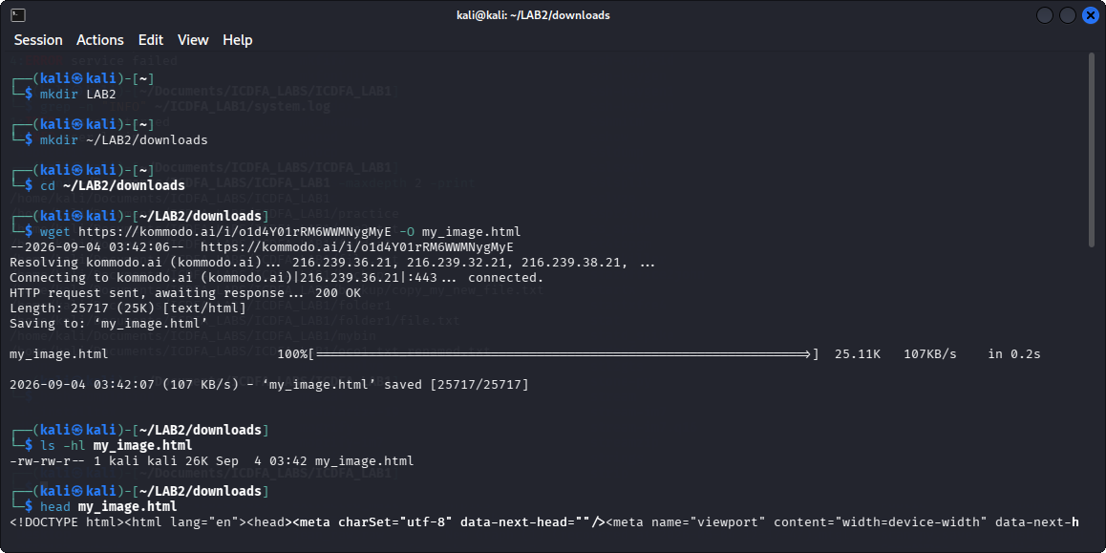
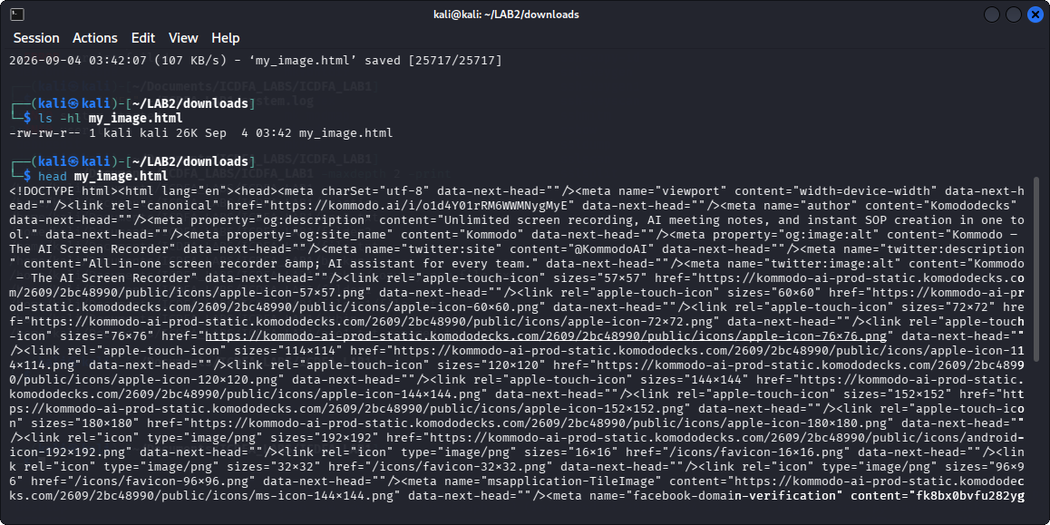
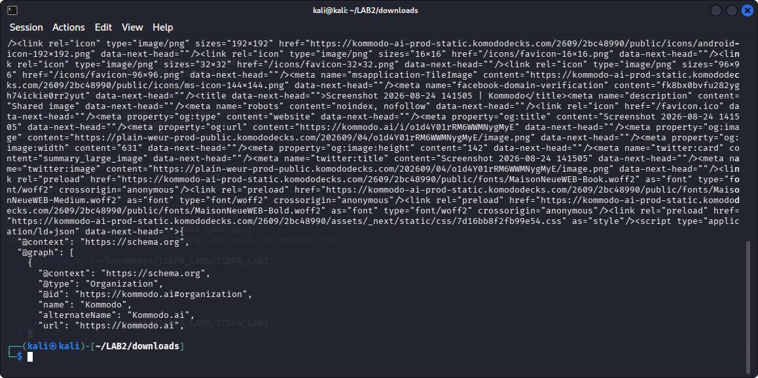

TASK 5 REPORT
EVIDENCE:
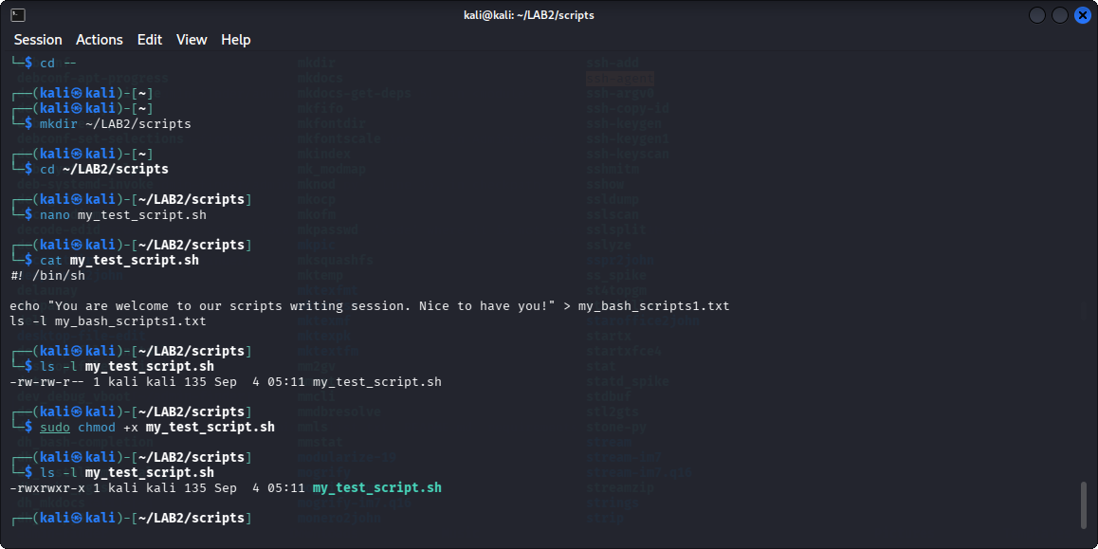
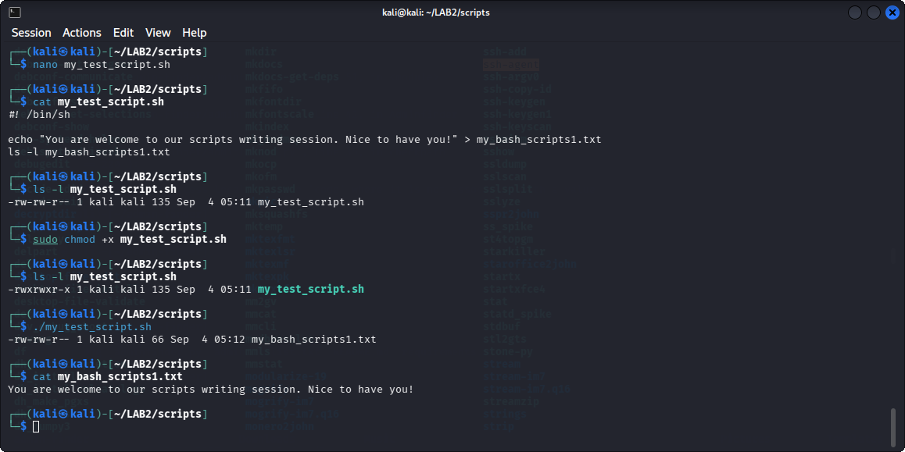
RESPONSE: #! /bin/sh tells the Linux of which shell interpreter should execute the script. It is just an instruction to the operating system about the script’s interpreter. In a lay man understanding it is saying Linux use this shell (sh) to run this script.

TASK 6 REPORT
EVIDENCE:
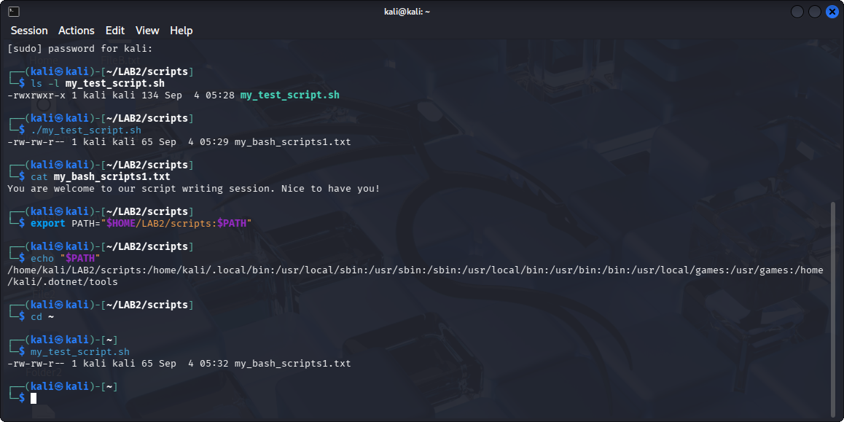

TASK 7 REPORT
EVIDENCE:
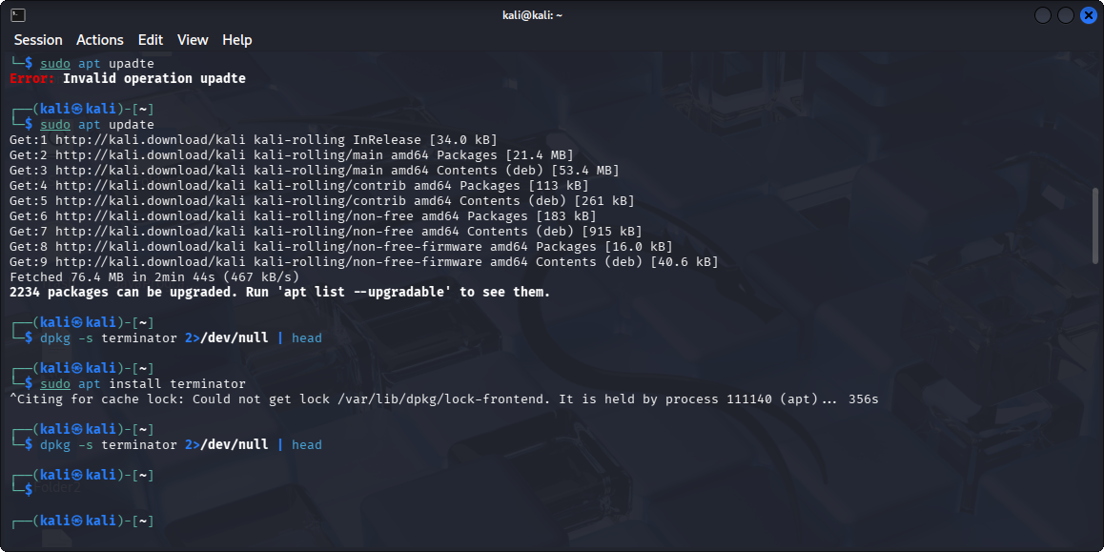

TASK 8 REPORT
EVIDENCE:
